Acute Angle
# Source: AI Source: Provided by: [Data Path: Persons Table -> ID Column: 1, Name_En Column: Motasem Essam] -> From: [ChatGPT] on [7/25/2026]
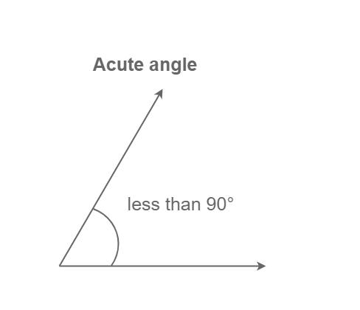
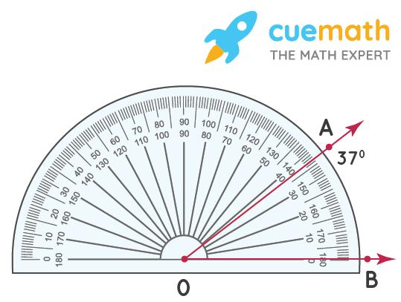
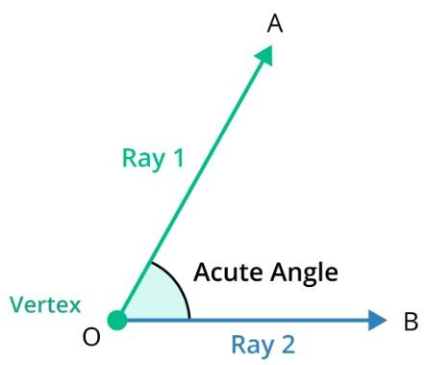
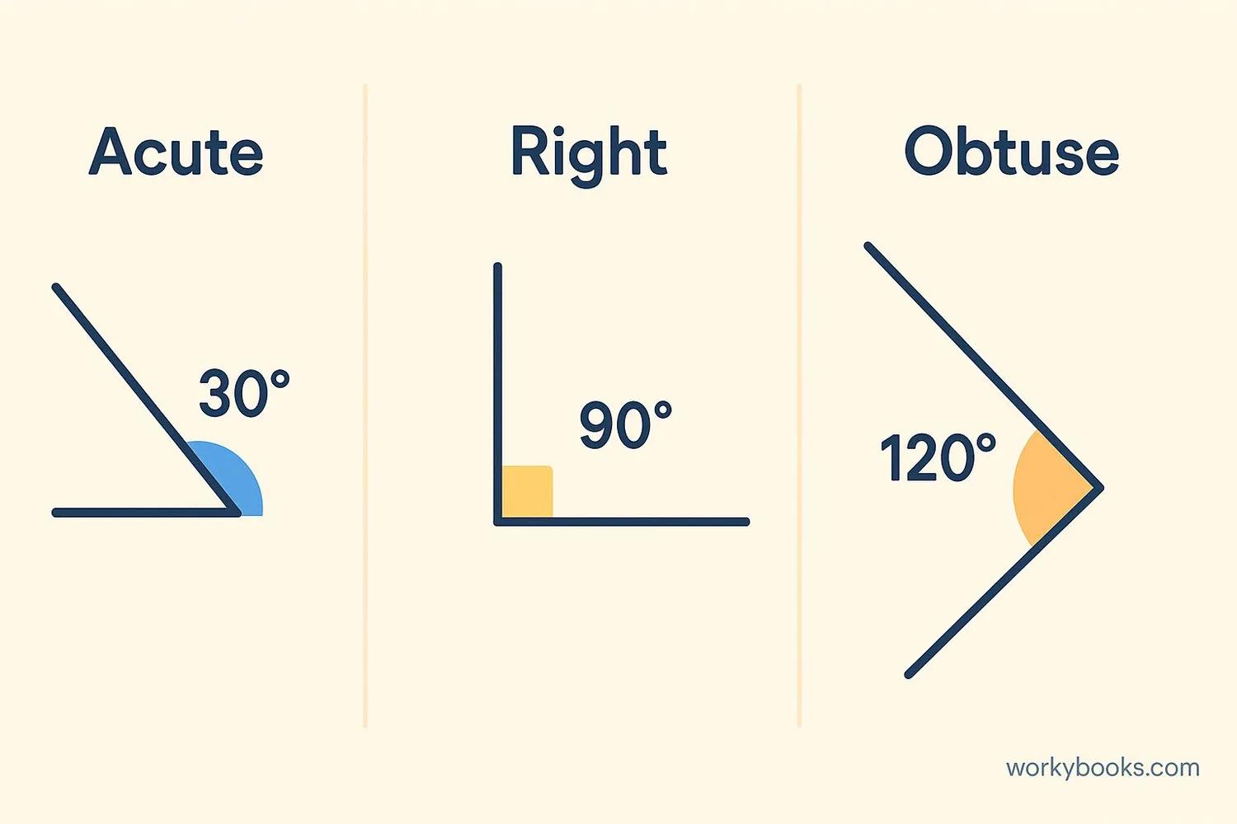
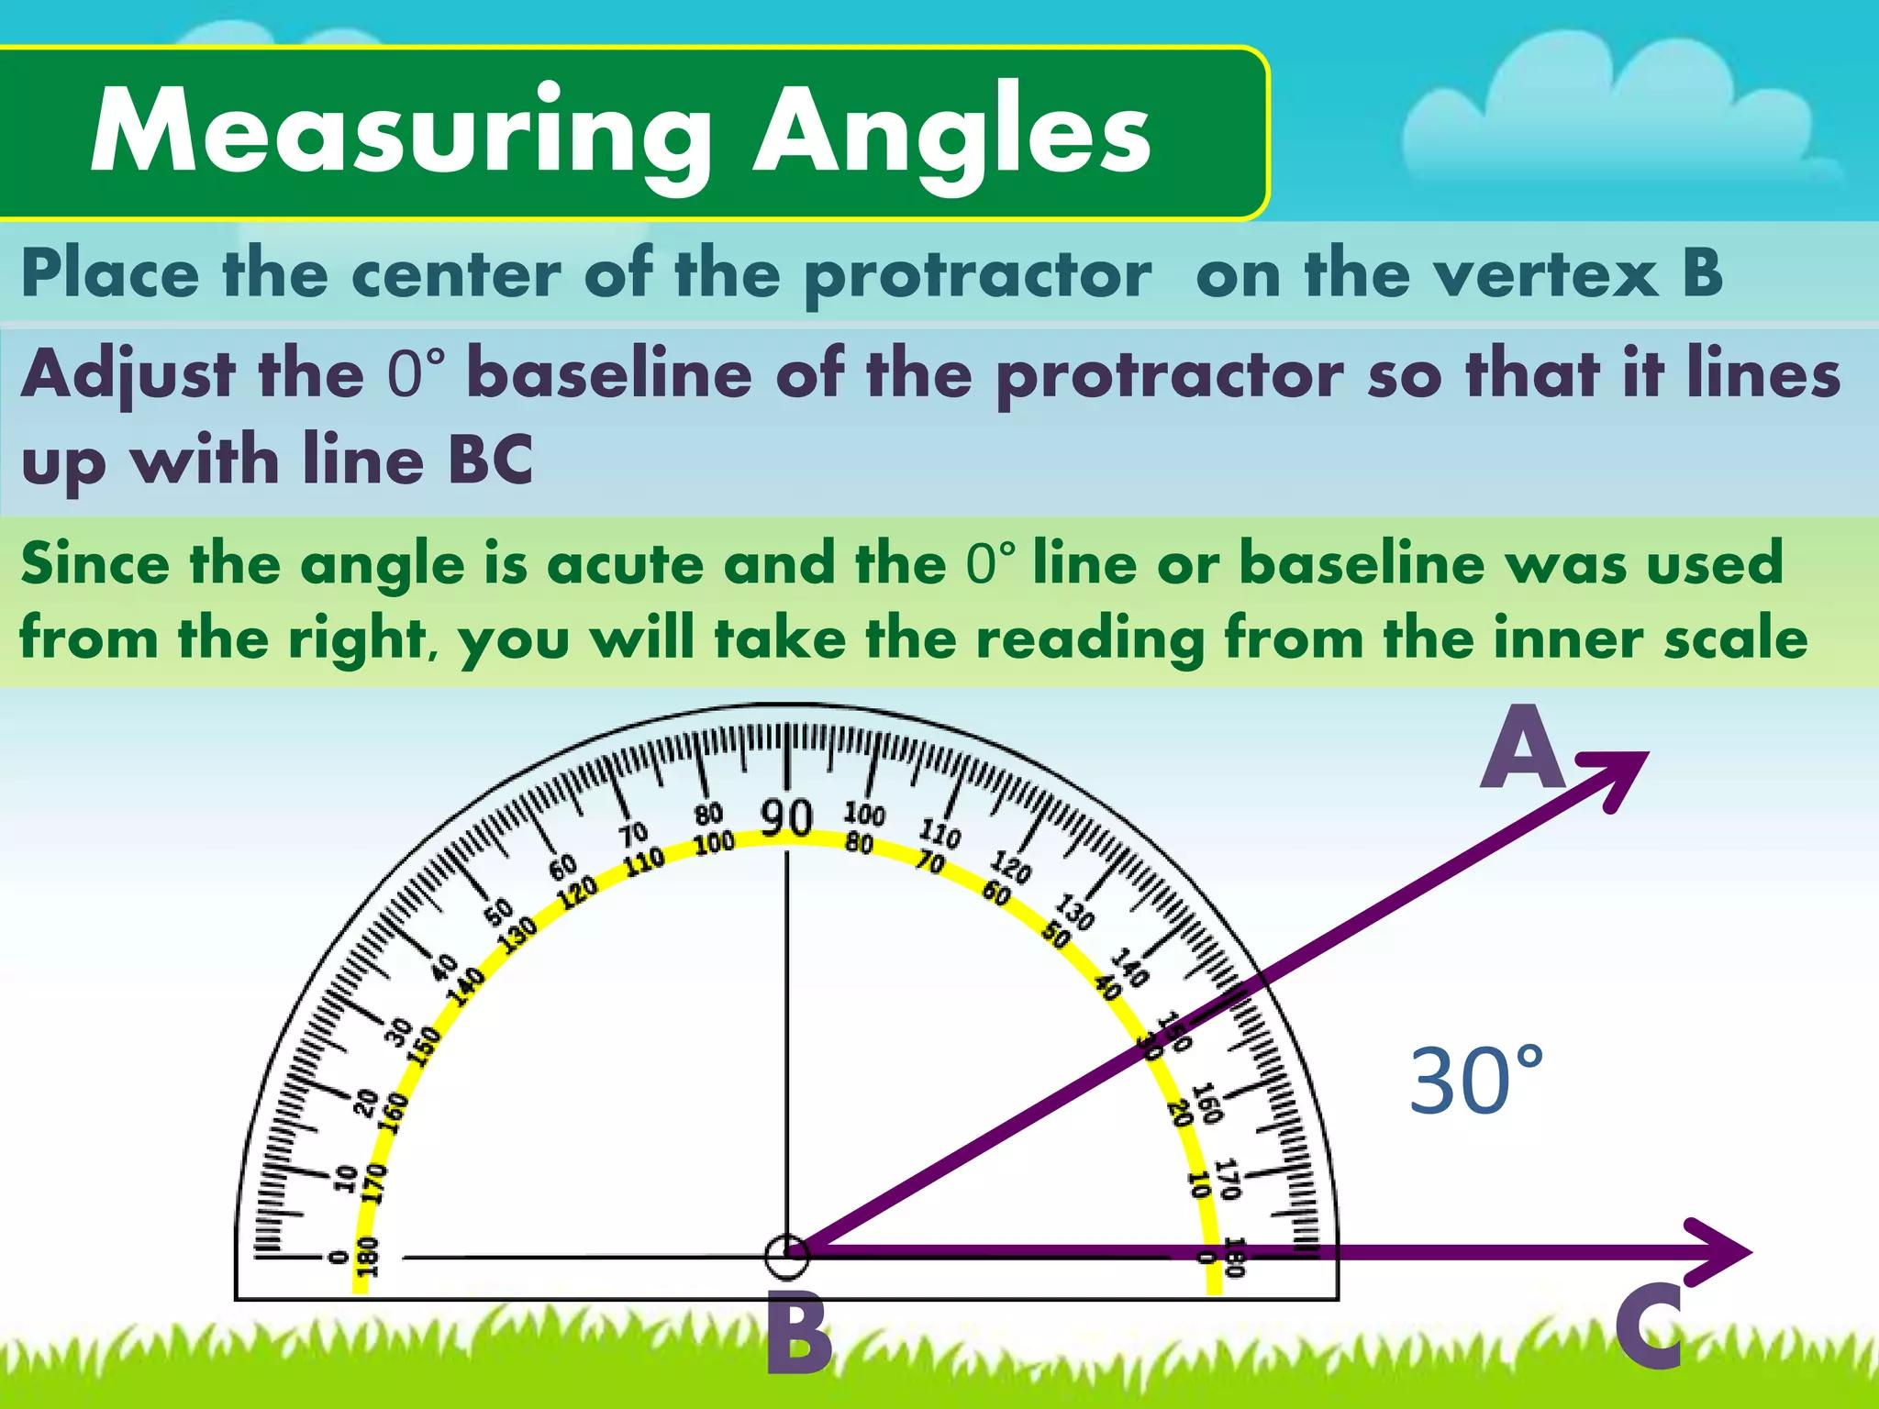
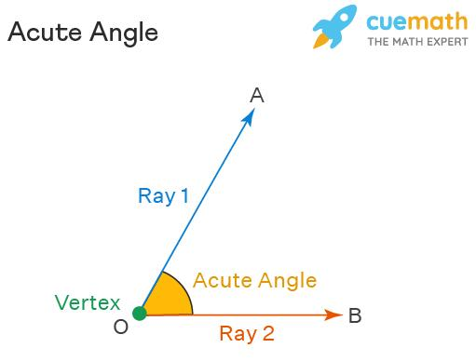

Definition
# Source: AI Source: Provided by: [Data Path: Persons Table -> ID Column: 1, Name_En Column: Motasem Essam] -> From: [ChatGPT] on [7/25/2026]
An Acute Angle is an angle whose measure is greater than $0^{∘}$but less than ${90}^{∘}$. It is smaller than a right angle and is one of the fundamental angle classifications in geometry.

Characteristics
# Source: AI Source: Provided by: [Data Path: Persons Table -> ID Column: 1, Name_En Column: Motasem Essam] -> From: [ChatGPT] on [7/25/2026]
An acute angle:
- Measures more than $0^{∘}$.
- Measures less than ${90}^{∘}$.
- Is smaller than a right angle.
- Is formed by two rays sharing a common vertex.
- Can be measured in degrees or radians.

Illustration
# Source: AI Source: Provided by: [Data Path: Persons Table -> ID Column: 1, Name_En Column: Motasem Essam] -> From: [ChatGPT] on [7/25/2026]
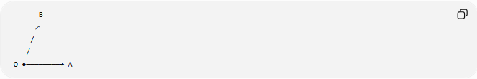
B
↗
/
/
O ●────────→ A
The opening between the rays is an acute angle.

Mathematical Representation
# Source: AI Source: Provided by: [Data Path: Persons Table -> ID Column: 1, Name_En Column: Motasem Essam] -> From: [ChatGPT] on [7/25/2026]
An acute angle satisfies:
$$0^{∘}<θ<{90}^{∘}$$
or, in radians,
$$0<θ<\frac{π}{2}$$

Examples
# Source: AI Source: Provided by: [Data Path: Persons Table -> ID Column: 1, Name_En Column: Motasem Essam] -> From: [ChatGPT] on [7/25/2026]
Common examples include:
$${15}^{∘} \\ {30}^{∘} \\ {45}^{∘} \\ {60}^{∘} \\ {75}^{∘}$$

Coordinate Geometry
# Source: AI Source: Provided by: [Data Path: Persons Table -> ID Column: 1, Name_En Column: Motasem Essam] -> From: [ChatGPT] on [7/25/2026]
Suppose two rays originate from
$$O\left(0 , 0\right)$$
Ray 1 passes through
$$A\left(5 , 0\right)$$
Ray 2 passes through
$$B\left(4 , 2\right)$$
The angle
$$∠AOB$$
is acute because its measure is less than
$${90}^{∘}.$$

Real-World Examples
# Source: AI Source: Provided by: [Data Path: Persons Table -> ID Column: 1, Name_En Column: Motasem Essam] -> From: [ChatGPT] on [7/25/2026]
Acute angles appear in:
- The tip of an arrowhead.
- Clock hands at certain times (e.g., 1:00).
- The peak of a roof.
- A pair of scissors opened slightly.
- The corner of some road intersections.

Properties
# Source: AI Source: Provided by: [Data Path: Persons Table -> ID Column: 1, Name_En Column: Motasem Essam] -> From: [ChatGPT] on [7/25/2026]
An acute angle:
- Is always less than a right angle.
- Has positive angle measure.
- Can be part of polygons and triangles.
- May be adjacent to other acute, right, or obtuse angles.
- Can be measured using a protractor.

Acute Angles in Triangles
# Source: AI Source: Provided by: [Data Path: Persons Table -> ID Column: 1, Name_En Column: Motasem Essam] -> From: [ChatGPT] on [7/25/2026]
A triangle may contain:
- Three acute angles (acute triangle), or
- Two acute angles together with one right or one obtuse angle.
Every triangle has at least two acute angles.

Applications
# Source: AI Source: Provided by: [Data Path: Persons Table -> ID Column: 1, Name_En Column: Motasem Essam] -> From: [ChatGPT] on [7/25/2026]
Acute angles are used in:
- Plane Geometry
- Coordinate Geometry
- Trigonometry
- Engineering
- Architecture
- Construction
- Surveying
- CAD (Computer-Aided Design)
- Robotics
- Computer Graphics

Advantages
# Source: AI Source: Provided by: [Data Path: Persons Table -> ID Column: 1, Name_En Column: Motasem Essam] -> From: [ChatGPT] on [7/25/2026]
Studying acute angles helps to:
- Classify geometric figures.
- Solve geometric proofs.
- Analyze triangles.
- Understand trigonometric functions.
- Design precise engineering structures.

Limitations
# Source: AI Source: Provided by: [Data Path: Persons Table -> ID Column: 1, Name_En Column: Motasem Essam] -> From: [ChatGPT] on [7/25/2026]
An acute angle:
- Cannot equal
$${90}^{∘}$$
- Cannot exceed
$${90}^{∘}$$

Comparison with Other Types of Angles
# Source: AI Source: Provided by: [Data Path: Persons Table -> ID Column: 1, Name_En Column: Motasem Essam] -> From: [ChatGPT] on [7/25/2026]
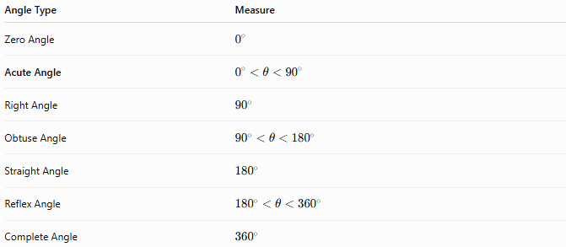
Angle Type | Measure
Zero Angle | $$0^{∘}$$
Acute Angle | $$0^{∘}<θ<{90}^{∘}$$
Right Angle | $${90}^{∘}$$
Obtuse Angle | $${90}^{∘}<θ<{180}^{∘}$$
Straight Angle | $${180}^{∘}$$
Reflex Angle | $${180}^{∘}<θ<{360}^{∘}$$
Complete Angle | $${360}^{∘}$$

Key Points
# Source: AI Source: Provided by: [Data Path: Persons Table -> ID Column: 1, Name_En Column: Motasem Essam] -> From: [ChatGPT] on [7/25/2026]
- An Acute Angle measures:
$$0^{∘}<θ<{90}^{∘}$$
- In radians:
$$0<θ<\frac{π}{2}$$
- It is smaller than a right angle.
- Every triangle contains at least two acute angles.
- Acute angles are fundamental in geometry, trigonometry, engineering, architecture, surveying, CAD, robotics, and computer graphics.

Conclusion
# Source: AI Source: Provided by: [Data Path: Persons Table -> ID Column: 1, Name_En Column: Motasem Essam] -> From: [ChatGPT] on [7/25/2026]
An Acute Angle is an angle whose measure is greater than $0^{∘}$and less than ${90}^{∘}$, making it smaller than a right angle. It is one of the most common angle types found in geometric figures, especially triangles, and plays an essential role in trigonometry and spatial analysis. Acute angles are fundamental in plane geometry, coordinate geometry, trigonometry, engineering, architecture, construction, surveying, CAD, robotics, and computer graphics, where they are used to describe inclinations, shapes, and directional relationships.

